Dharisha.G – Frontend [React]

Section A
1)Explain the difference between *DBMS* and *RDBMS*.
DBMS-Data Base Management System
- It is used to store non-relation data also
- Less secured
RDBMS-Relational Data Base Management System
- It can store only relational data
- Highly secured
2) What is a *Primary Key*? Why is it important?
Primary key is used to find unique record in rows.
Only one primary in a table
Null values are not allowed
Importance:
If two members having same name in college. How to know? who is who? For that we use student Id to differentiate them . Here, student Id is the Primary key
3) What is a *Foreign Key*?
Foreign Key is used to connect two tables.
One column is repeated in another table for reference.
4) Explain the difference between a *Row* and a *Column*.
Row – complete record of one person or thing
Eg: student table – one row belongs to the one student
Column-one type of information
Eg: Name of students, Aadhar number
5) Name any *four SQL commands* and explain their purpose.
DDL-Data Definition Language
- Create
- Alter
- Drop
- Truncate
DML-Data Manipulation Language
- Insert
- Update
- Delete
DCL-Data Control Language
- Grant
- Revoke
DQL-Data Query Language
- Select
TCL-Transfer Control Language
- Commit
- Rollback
- Savepoint

Section B – SQL Queries
Write SQL queries to:
- Display all employees.
SELECT * FROM Employee
- Display employees from the IT department
SELECT * FROM Employee
WHERE department=’IT’
- Display employees whose salary is greater than 55,000
SELECT *FROM Employee
WHERE salary>55000
- Update John's salary to 52,000
UPDATE Employee
SET salary=52000
WHERE name=’John’
- Delete the employee with EmpId = 102
DELETE FROM Employee
WHERE EmpId=102;
- Display all unique department names
SELECT DISTINCT Department
FROM Employee;
Section C – Practical
Create a *Student* table with the following columns
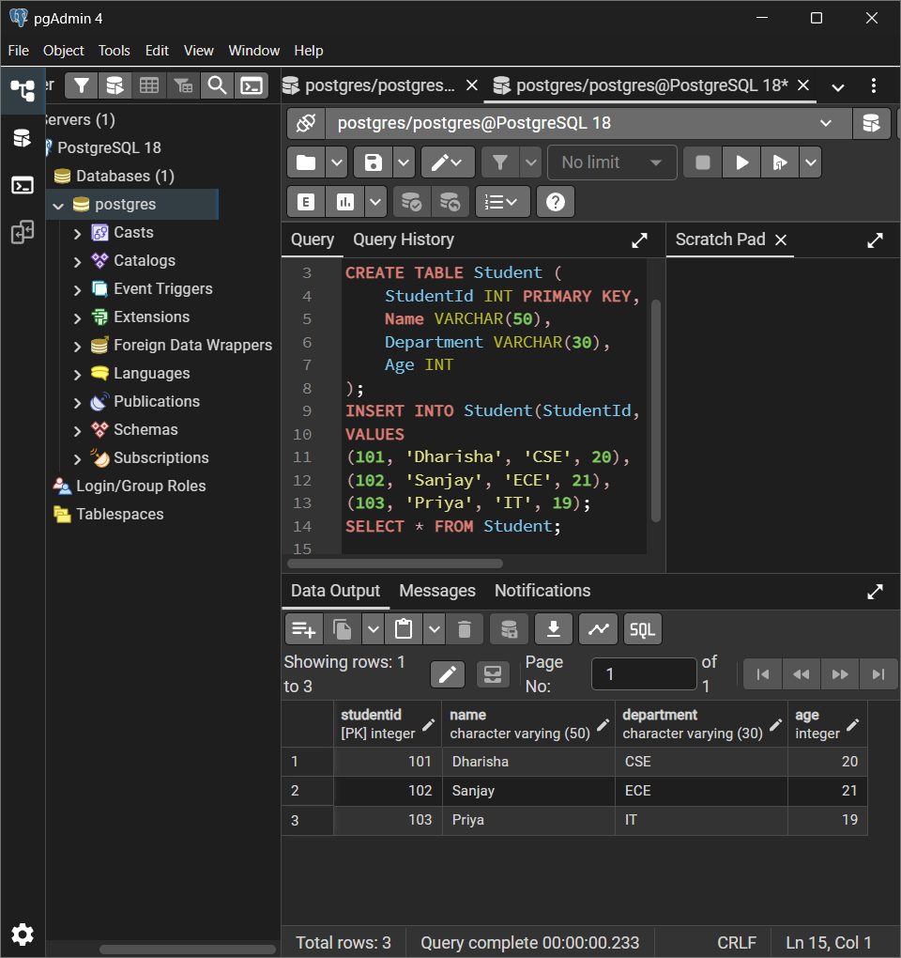
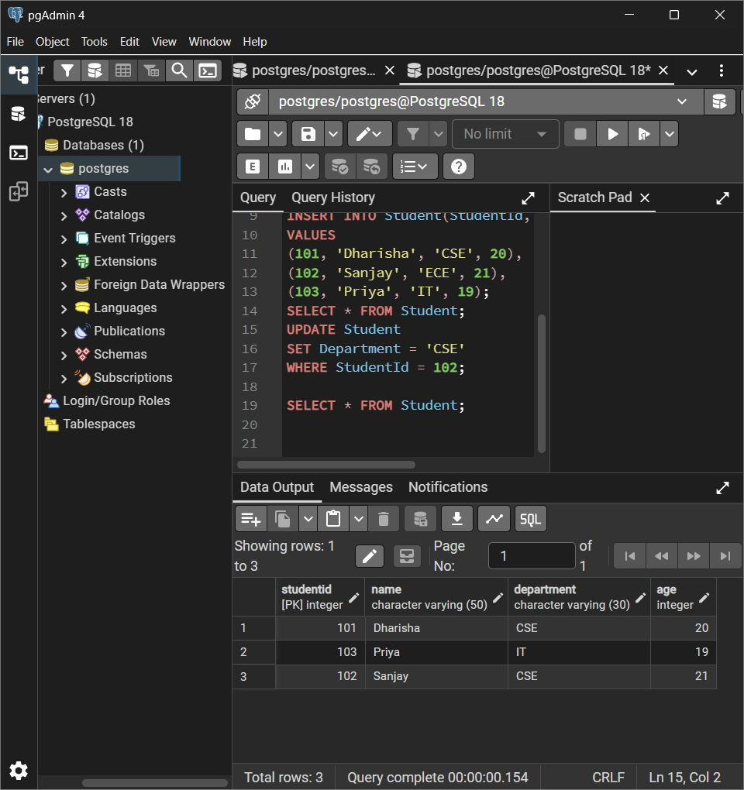

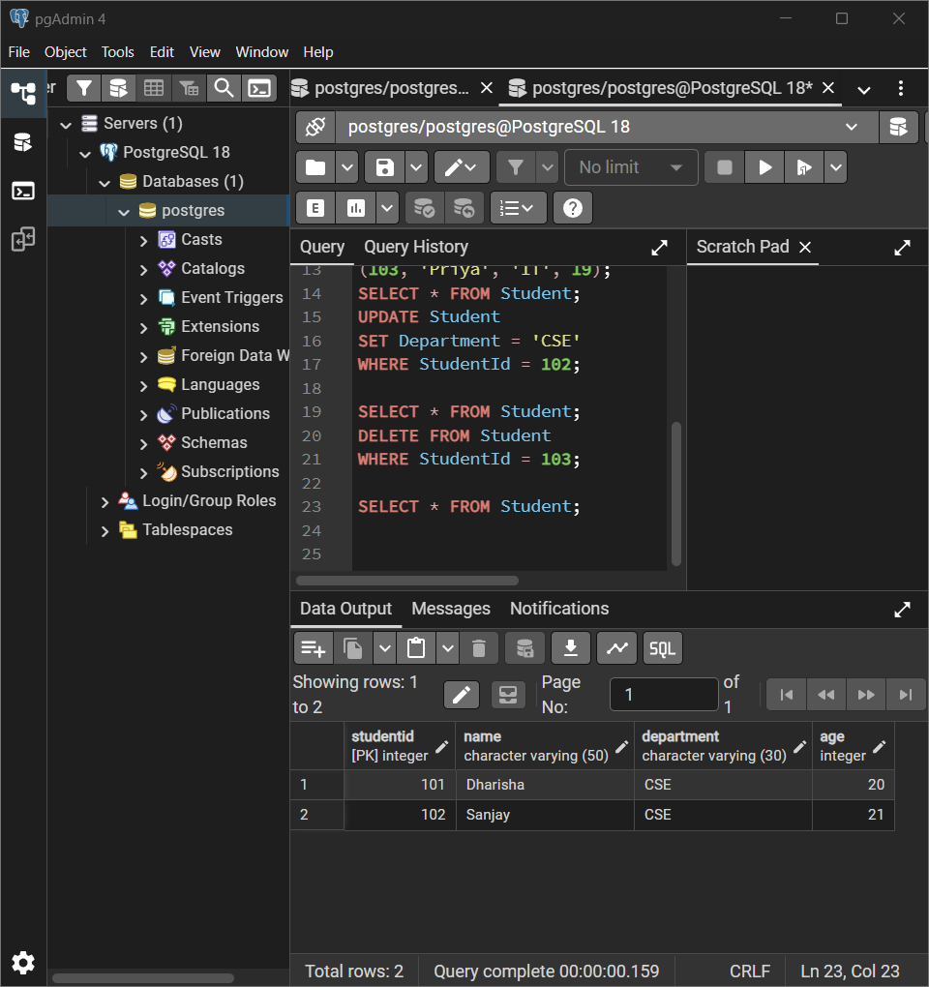

SQL QUERIES:
CREATE TABLE Student (
StudentId INT PRIMARY KEY,
Name VARCHAR(50),
Department VARCHAR(30),
Age INT
);
INSERT INTO Student(StudentId, Name, Department, Age)
VALUES
(101, 'Dharisha', 'CSE', 20),
(102, 'Sanjay', 'ECE', 21),
(103, 'Priya', 'IT', 19);
SELECT * FROM Student;
UPDATE Student
SET Department = 'CSE'
WHERE StudentId = 102;
SELECT * FROM Student;
DELETE FROM Student
WHERE StudentId = 103;
SELECT * FROM Student;

